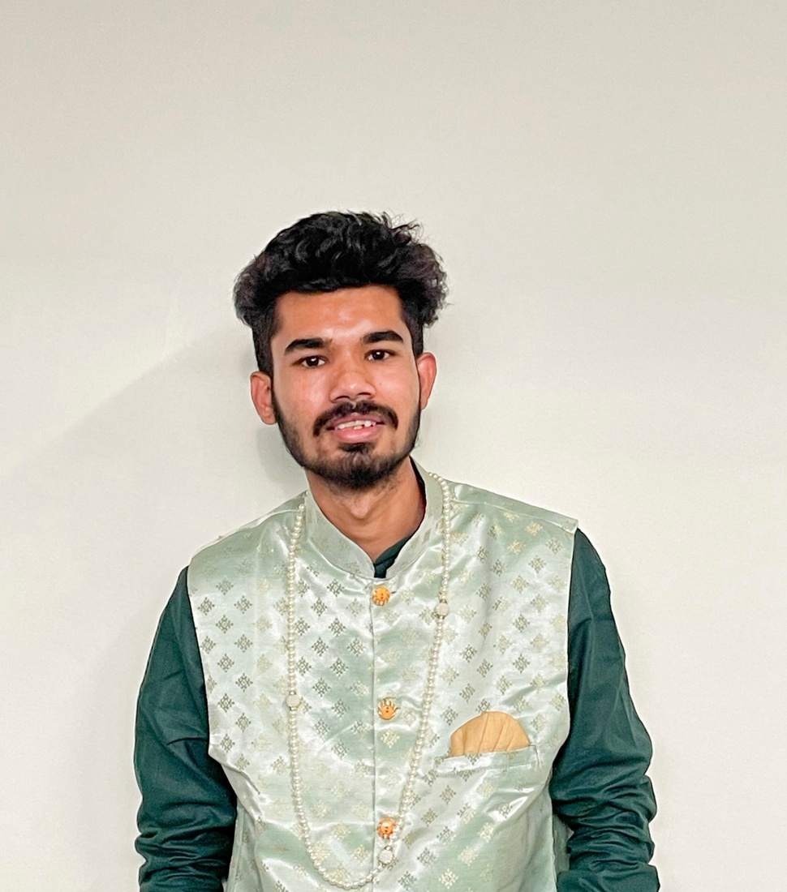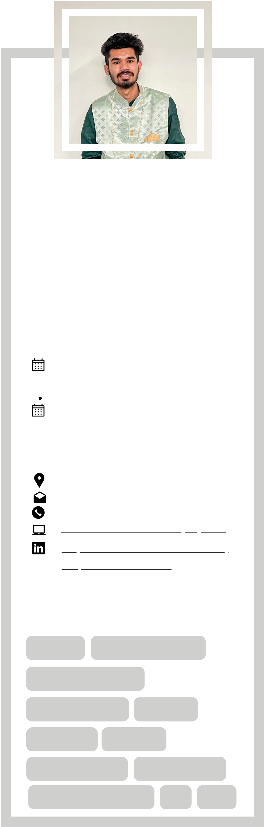

**Career Objective**

Secure a responsible career opportunity to fully utilize my training and skills, while making a significant contribution to the

**Tejas Pawar** DATA SCEINTIST / FULL STACK

DEVELOPER / SUPPLY CHAIN

success of the company.

**Work Experience**   
LLAJJA - Sustainable Clothing Brand

**Business Analyst + Full Stack Web Developer**

|  |  |  |
| --- | --- | --- |
|  |  | Jul 2021 - Sep 2021 |
| **Education** |  | While working at LLAJJA my responsibilities |

Bachelor of Technology in   
Computer Science Engineering   
with specilization in Data Science **D. Y. Patil International University**  August 2019 - Current

**Add On:**   
 Supply Chain Management.

Nov 2021 -March 2022

were to do research and provide solutions to problems and design a website accordingly.

 Tools Used: PHP, VS Code, Python, Jupyter

Godaamrut Farmers Producer Company Ltd   
**Project Manager + Data Scientist**   
 Jan 2021 - May 2021

|  |  |  |
| --- | --- | --- |
| **Contact** |  | Converting theoretical research data into |
| practical applications by designing software |

Akurdi-Pune, 411044   
beingtejas4912@gmail.com   
[+919694280807](https://github.com/tejasy4912)   
[GitHub](https://github.com/tejasy4912) [Username: @tejasy4912](https://github.com/tejasy4912)

[https://www.linkedin.com/in/tej as-pawar-2919ab1b0/](https://www.linkedin.com/in/tejas-pawar-2919ab1b0/)

solutions and automation tools for giving better agriculture services to farmers.

 Tools Used: R Programming, R Studio, Python, Jupyter, Kaggle. Tableau.

**Projects**   
Young Dumb Broke | Youth Lifestyle

|  |  |  |  |  |
| --- | --- | --- | --- | --- |
| **Skills** | | | Platform  **Start-up** | |
| **Python** | **R Programming** | |  | A start-up in its growing phase. It focuses |
| on the overall development of the youth by focusing on sections like self-care, Skills Learning, self-growth events, mental health, and many more.  Diabetic Retinopathy Prediction | |
| **HTML, CSS & JS** | | |
| **JetBrains IDE** | | **Jupyter** |
| **Power BI** | **Tableau** | |

**Data Analysis**  **Data Mining**

**Big Data Analysis**  **ML**  **NLP**

**Data Science**

 automatic detection for **diabetic**   
 **retinopathy** using non-dilated retinal images at early stages